

**Robocon Auto Car Challenge**

Task 1

**Department: Electronic**

Made by: MOHAMED SHARFI ABDELGADIR *“A21EE9137”*

**Mentors: Kar Wai, Yie Kun**

**Table of Contents**

**Documentation** . 3

I. BluePill: 3

II. LM324 4

III. L293D 5

IV. servo motor 6

V. UART communication 7

VI. Soldering 7

# Documentation.

This document will summarize each of main components (IC: integrated circuits) that I’m going to use in order to build my auto car or “line follower car”. Blew are the list that has been mentioned:

1. Bluepill.
2. LM324.
3. L293D.
4. servo motor.
5. UART communication
6. Soldering Gun

## BluePill:

BluePill or STM32F103C8T6 is basically a microcontroller that using code will be able to program and control our Auto Car

But before the pinout connection picture there is several notes to consider before connecting to stm32

* To upload program, or booting you need to use Pin A9 (TX) and A10 (RX) ONLY because They are hardwired for this purpose. Even though we got other Tx, Rx pins such as B7, B6
* Also, there is specific pins for input analog we can use other pins but those are preferable which are form **A0-A7 and B0, B1**
* pulse-width modulation (PWM) which can be used as speed controller for the motor because it changes voltage as pulse
* 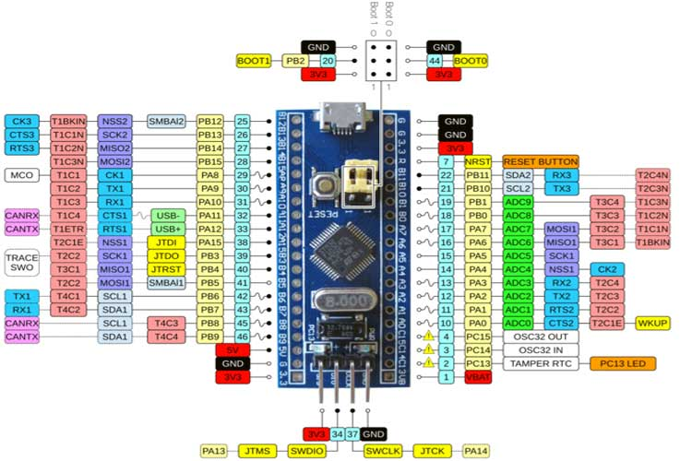

Figure ‎0‑1 BluePill Pinout

## LM324

LM324 which are basically a Operational Amplifiers which is compares two voltage between non inverting and inverting input so let’s call non-inverting **V+** And inverting **V-**

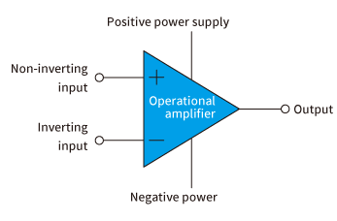

Figure ‎0‑2 OpAMP basic

The output has only two ways to operate:

* If V+ is bigger than V- then our output will be (positive power supply) ***(VCC)***
* If V+ is smaller than V- then our output will be (negative Power) ***(VEE)***

***We will use this chip to control the sensitivity and the output from sensors.***

***Sensor >>> LM324 >>> Digital signal to your STM***

Figure ‎0‑3LM234 Pinout

**NOTE THAT IT HANDELS 30 V MAX *(referring to the datasheet).***

## L293D.

L293D or as I called it the heart of the Motor it takes signal from controller to decided when to speed, stop and rotate anti clockwise the motor the chip can handle 4 motors but in half bridge mode 2 motors connected to pin.

Figure ‎0‑4

Since we have 2 motos only we will use TWO FULL H BRIDGE.

Figure ‎0‑5 L293D Full H mode

* To control the speed, we just need to adjust the value from STM which is (PWM) input. (pin 2,7,10 ,15).
* And to adjust the direction we need to decide which pin to be high which to be low between pin 2 and 7 (first motor) and 15, 10 for the second motor.

### Important Notes regarding L293D.

**Why we need to control both EN and A1?**

**Answer:**

## Servo motor.

Servo Motor is just motor that got a limited line of motion that can be controlled to, and we will usually use it to control the two wheels rotation (turn left or right)

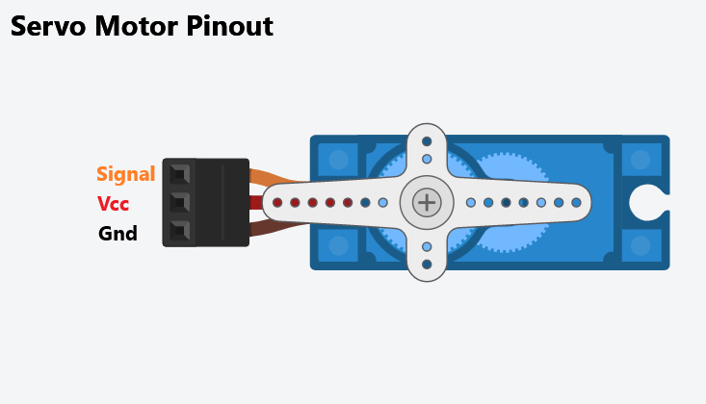

Figure ‎0‑6 Servo motor Pins

All we need to do to control the servo motor in the signal input which will be taken from the STM32 (Bluepill) or our controller. The output will be taken from one of the PWM pins same as normal Motor in *figure 0-5*

Please note that the angle of the desired position should be less than the max angle of the servo which is 180 degrees.

The Working principle is that servo uses the width of the input signal (PWM) to control the angle starting from 1000us to 2000us.

|  |  |
| --- | --- |
| **Angle (Degrees)** | **Pulse Width (μs)** |
| 0° | 1000us |
| 45° | 1250us |
| 90° | 1500us |
| 135° | 1750us |
| 180° | 2000us |

## UART communication.

UART is a way to communicate between external devices or pubs and your controller such as normal USB UART that we used to program our STM.

But this time from my understanding we will going to use **hc-06** which is wireless Bluetooth to control our robot manually.

Figure ‎0‑7Pinout for the HC-06

## Soldering.

**DO THIS BEFORE YOU START SOLDERING:**

* Make sure your table is clean (Cleanliness is everyone’s responsibility.)
* Wear Mask or prepare a mini fan. (Fume extractor.)
* Before plugging it make sure your soldering stand is in a good position and STABLE.
* Make sure to bring your own FLUX and SOLDER WIRE.
* Get a MAT (mat can resist the temperature and heat)

**DO THIS DURNING YOUR SOLDERING:**

* Make sure to keep table clean
* Get A sponge to clean your soldering tip
* Be careful of your surrounding and other electrical devices that you may damage.
* Make sure that your stand is in a good position.

**DO THIS AFTER YOUR SOLDERING:**

* Cool and test your PCB or Controller using multimeter (peeep sound)
* Unplug your soldering Gun after you apply some solder or flux (save the tip from Rust).
* Clean the table (Cleanliness is everyone’s responsibility.).
* Wash your hand LEAD IS VERY TOXIC SAME AS FLUX.

# Questions

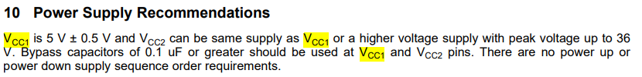

# Final Schematic &PCB Layout:

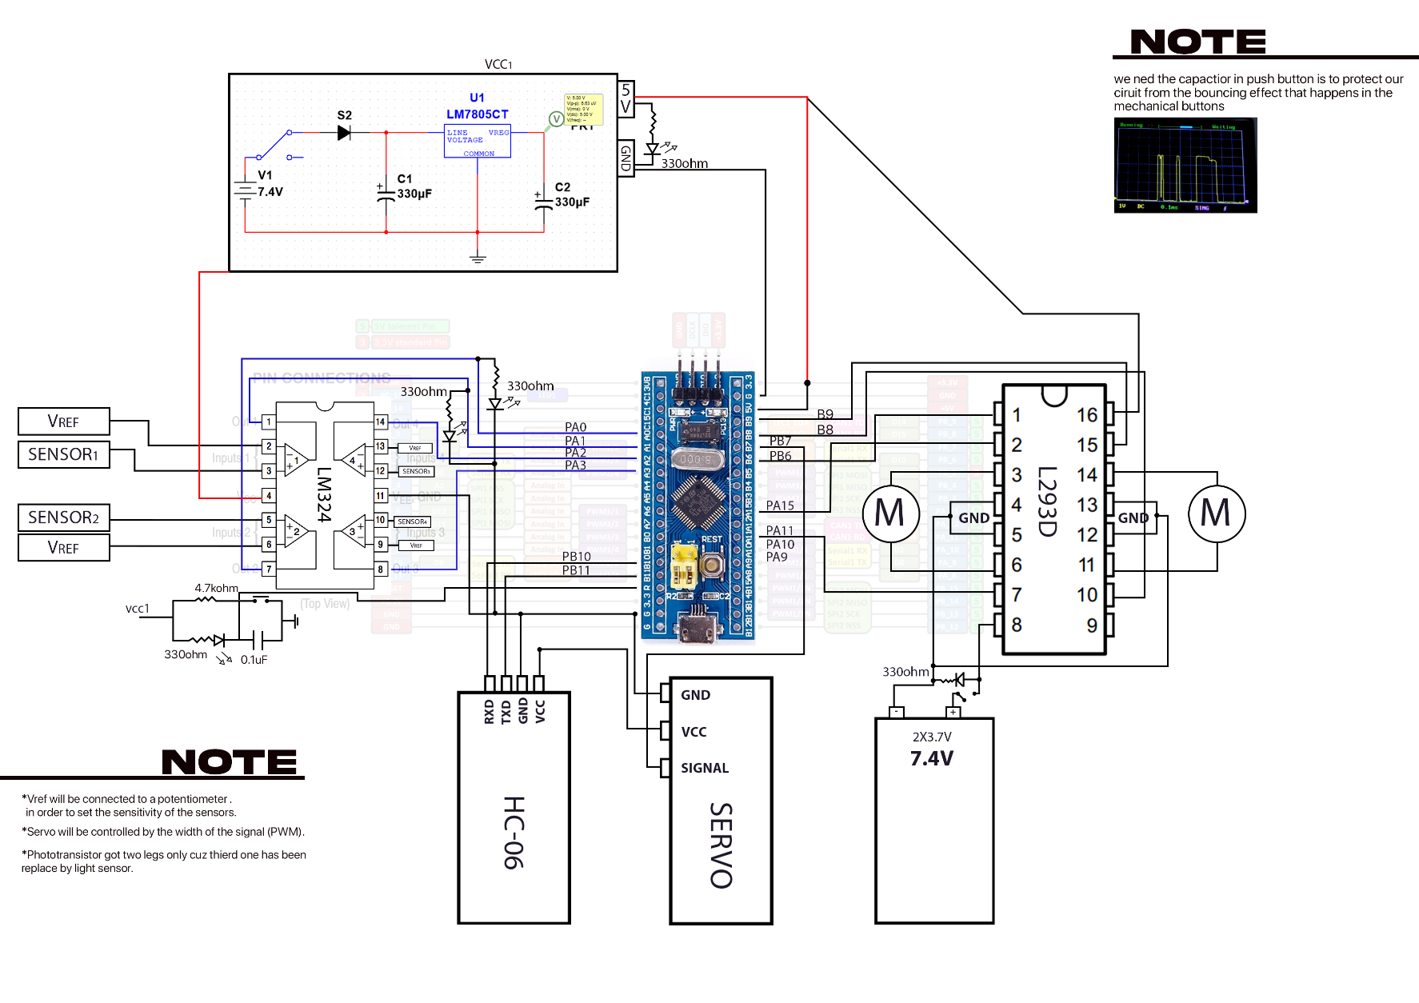

**M: Motors**

